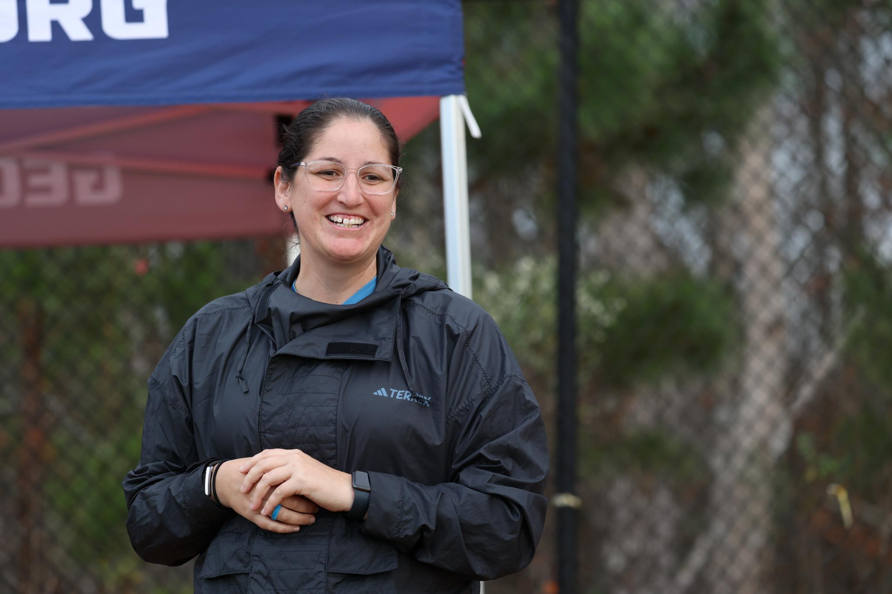
Cristina Coca: The mind behind the tournament you’re playing in
Cristina Coca’s favorite part of her job isn’t winning trophies. It’s handing them to other people.
As the director of tournament and event operations for Georgia Soccer, Coca plans the logistics behind events like State Cup, Presidents Cup and ODP competitions. She’s booking facilities, hiring referees and coordinating schedules with coaches. It’s tough work, a “constant jigsaw puzzle,” said Coca, juggling the needs of around 70 teams for a state tournament event. But, at the end of the weekend, it’s all worth it.
“When those games get played on the field and then the teams at the end of the event lift those trophies, and you see them celebrating — that's why I do it,” Coca said.
Working in event operations “kind of fell in (Coca’s) lap,” she said. A former collegiate goalkeeper, Coca was teaching high school and coaching with the West Florida Flames youth club when she walked into the club’s administrative office and asked the president, “What can I do to get more involved?” She wanted to have a bigger impact within the organization, so she began working with the club’s media and website, which turned into scheduling requests as a league liaison, which turned into a new job as a league admin.
She “hadn’t known that role had existed,” before. Of course, though, someone had to schedule the games Coca had grown up playing in, then coaching.
“I was so set on coaching, and then I started doing this and I'm like, ‘Wow, I can affect so many players on the field,’” Coca said. “I can make a bigger difference than just my roster of 22-24 players. I'm reaching the entire state.”
Coca’s current work in Georgia isn’t totally new to her. While in Florida, she served as Florida Club League’s Director of Competition, then Florida Youth Soccer Association’s Director of Competition.
In addition to coaching and coordinating events, Coca works as with US Youth Soccer to organize Olympic Development Program and state champion teams’ participation in regional competitions.
“I help them with their rosters, I make sure they know all the rules, I help them with player eligibility, hotel information,” Coca said. “You name it, I'm making sure that they comply with everything. That way, when they go to these events, they just show up on the field and play.”
Coca even gets to travel with the teams to these regional and national events, where she wants players and coaches know they can rely on her as their state representative. Last year, a girls’ team from Savannah was knocked out of the regional tournament. Then, Coca got to deliver the news that they earned a wildcard bid to the national championship. Players’ tears of sadness turned into tears of joy.
“It’s the best, forming those relationships with the teams and players,” Coca said. “Because I'm no longer a coach, I'm not directly involved with them anymore, so it's great to be able to give them those opportunities to be able to do stuff like that.”
Directing events requires plenty of communication and conflict resolution, just like coaching — which Coca still pursues, like coaching goalkeepers for the Women’s Premier Soccer League’s Georgia Impact last summer.
“I deal with players, coaches, club directors, presidents, moms and dads, grandmas, grandpas, you name it,” Coca said. “If there’s an issue, it requires that empathy of listening to them and understanding, a skill that I've kind of developed over the years, and I think, honestly, I have thanks to my experience as a high school teacher.”

