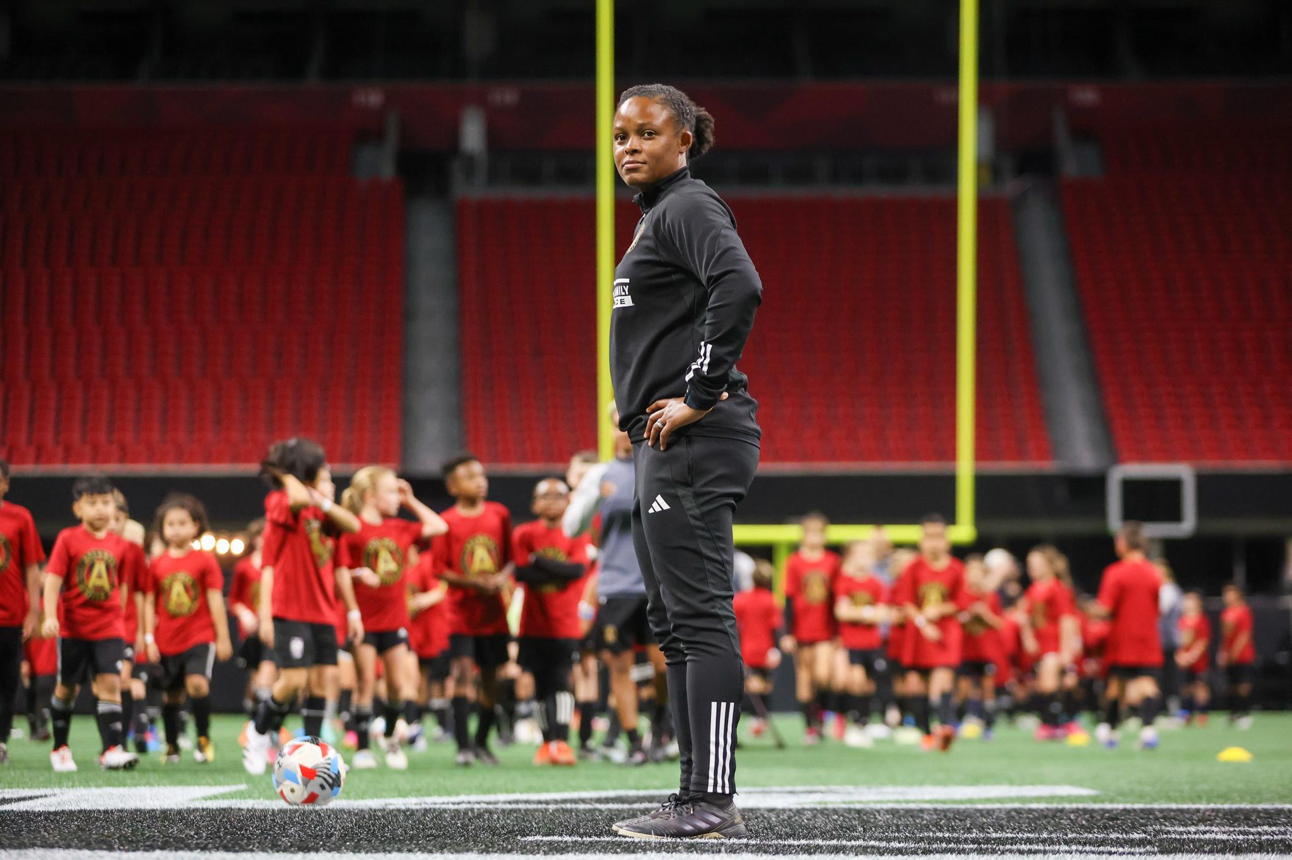
Leigh Jakes: For club and community
When Leigh Jakes goes to work and steps onto the soccer field, her opponents now aren’t really a match for the former pro player. Oftentimes, the other players barely come up to the height of Jakes’ waist. Some are as young as three or four.
Jakes is the Youth Development Director for Major League Soccer club Atlanta United FC. There, she leads camps, clinics, and training programs for young players in Georgia.
Atlanta-raised, Jakes herself is an example of a Metro Atlanta soccer player who fell in love with the sport, traveled the world playing it, and is now helping others do the same.
“Soccer is an opportunity to learn a new language,” Jakes said. “It's an opportunity to expand your worldview, and it's an opportunity to play in a beautiful, fluid, and connected game.”
Tagging along with her older cousins, Jakes picked up soccer at age six. The sport would take her to Northwestern University, where she played collegiately before suiting up professionally with the Chicago Red Stars and clubs in Sweden and Finland.
Her collegiate and professional experience exposed Jakes to a variety of different coaches and training environments — some great, some toxic, all helping her learn more about the kind of environment she wanted to cultivate for young players.
“We're going to be organized, and we're going to communicate well, and we're going to make sure it's a safe environment. That's what ‘professional’ encompasses for me,’” Jakes said. “And specifically working with girls, just making sure that it's a safe place for them, psychologically.”
But as a player, Jakes didn’t yet know what a future in soccer looked like for her, beyond the field. Besides, thinking about that sort of shift in roles was, to Jakes, thinking about the end of her playing career. “I wouldn’t even allow my mind to go that route,” she said.
Like many players, Jakes dealt with injury throughout college and her pro years, and while she was back home playing semipro soccer with the Atlanta Silverbacks, with an eye on returning from injury and heading back overseas, a former teammate of hers saw that Jakes was in Atlanta and reached out. She wanted to see if Jakes might get involved with the nonprofit Soccer in the Streets.
Soccer in the Streets offers affordable and inclusive camps and clinics for young Atlanta soccer players, reaching communities who might not already be tapped into the traditional soccer space due to steep prices or a lack of resources.
“The cool thing about Soccer in the Streets is that it’s about life as well, giving them resources for conflict resolution and social-emotional regulation, in addition to exposing them to a global sport, to help them see outside of their neighborhood,” Jakes said.
Connections made through Soccer in the Streets recommended Jakes to help with Atlanta United FC’s first summer camp season when the MLS club was founded. She worked at camps until a full-time position opened up as the club’s camps and clinics manager later that year.
Now, for Atlanta United, Jakes helps connect young players, ages three to 16, to the MLS club through seasonal weekly clinics, summer camps, and training programs that feed into the academy. Her job requires creativity, catering different programs for new players and experienced ones, and even crafting a virtual soccer program to help kids socialize during the height of the COVID-19 pandemic.
“I have rules I give players every session: how can they be a good teammate, how they can be respectful, how they can be a hard worker,” Jakes said. “I think that's something that I'm learning about myself, even in coaching courses: I'm wearing an educator hat as well.”
Jakes is also the chair of Atlanta United’s Diversity, Equity, and Inclusion (DEI) council. Her interest in increasing diversity in sport goes back to her college days, when she researched the experiences of Black female collegiate athletes competing in low-representation sports like soccer, lacrosse, and field hockey.
As a Black female athlete, Jakes grew up aware of the importance of having “tangible heroes,” she said, seeing players and leaders that looked like her in soccer. In Atlanta United’s youth programs, Jakes wants her team of coaches to be those diverse role models for their players.
“Coaches need to look like the communities that we serve,” Jakes said. “If you see it, you feel like you can be it. It also helps to be able to speak a certain language, whether it's actual language or just a cultural exchange.”
“It's been a big focus of our departments to bring in coaches of different backgrounds — not just ethnicity, gender, sexual orientation, age, but also soccer experience, people with different levels of licenses and different coaching backgrounds.”
Jakes recently received her B coaching license through U.S. Soccer, with goals of one day, perhaps, becoming a general manager of a women’s club or working in a soccer governing body. She wants to cultivate a safe soccer environment as a conscientious female leader who’s seen the game from the players’ side.
“When you don't have female decision makers, or decision makers with diverse backgrounds, then female players and coaches are just going to be faced with the same old thing,” like microaggressions or discrimination, Jakes said. “It's important to be in those leadership roles.”

