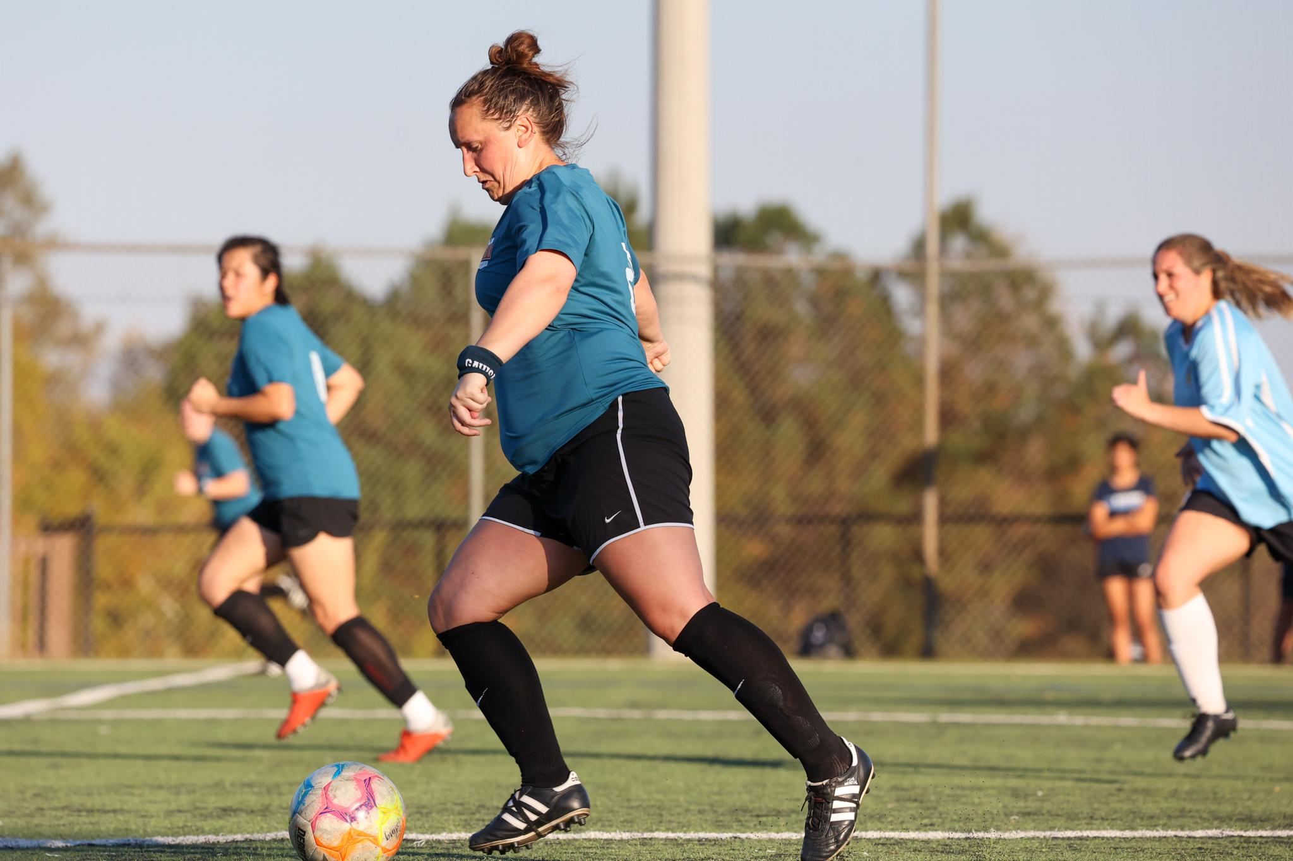
Michelle Tweedy and GAWSA’s push to get more women playing the beautiful game
During the day, Michelle Tweedy works as General Electric’s sales operation leader for contractual services and gas power for the Americas region. On the shelf behind her desk where she works sits a photo of a soccer team.
It’s not any of her youth teams, or the team she played on at Georgia Southern. It’s a group of women she’s played soccer with for nearly a decade, ever since she was recruited by a friend to join a Georgia Amatuer Women’s Soccer Association team.
With GAWSA, Tweedy has been a player, team captain, vice president and, now, president of the league.
“I’m a generally pretty organized person,” Tweedy said, and so she had stepped into a captain role for her team, scheduling matches and sending emails.
That experience allowed her to peek behind the curtain of how the league was run, and Tweedy saw opportunities for improvement. Elected to the five-person board of directors, Tweedy helps oversee the league’s communication, leadership and growth.
Founded in 1985, GAWSA offers a chance for women over 18 — both new players and long-experienced players, like Tweedy — to play organized soccer in the Atlanta area. Historically, women have had less opportunities to continue organized sports into adulthood; men’s leagues, or co-ed leagues composed mostly of men, are easier to find than all-women leagues.
“Having soccer opportunities for both women and men means everything, right?” Tweedy said. “I think if you look at any studies, statistics, there's plenty of research out there that points to having both sexes represented, you create a more organic organization, you create more opportunities, you have different ideas.”
In the fall and spring GAWSA seasons, 18 teams compete in full field, 11v11 matches; in the winter and summer, teams play shorter 7v7 games. At any given point, 300 to 450 women lace up their cleats to compete in GAWSA on Sundays, in one of the league’s three different level of competition.
“We have players who are 18, and we have ladies in their 80s,” Tweedy said. “We have women who have played professionally, semi professionally, a lot of former college players, and then we have women who've never played before but want to learn the sport. We have every skill level and just about all the ages covered.”
From all across Metro Atlanta, these women come together to compete and talk soccer. This past summer, the Women’s World Cup upsets and final tournaments of legendary women’s soccer players were the frequent pregame conversations of Sunday GAWSA matches. A GAWSA team of around of a dozen women even flew to watch the tournament, co-hosted by Australia and New Zealand.
“The best part of GAWSA is the camaraderie — That's what it comes down to. That’s why a lot of women keep playing,” said Tweedy. “It’s the sisterhood of the league. The women, they’re incredible.”
Tweedy said her proudest accomplishment as president has been growing the league by adding several new teams. Now, they don’t have a participation problem. They actually have so many individual players wanting to join that they need new captains willing to form additional teams so that, ideally, no interested player gets left off a roster.
With one more two-year term to serve before hitting the two-term, four-year limit, Tweedy hopes to continue leading GAWSA with a “candid approach to leadership” as she balances wearing the hats of player, captain and president and competes in the sport she loves.
“Soccer gave me, and still gives me, friendships and opportunities, and not only opportunities for school, but the opportunities for travel and to see new places, connect with new people,” said Tweedy. “I work for an international company, and a lot of times, when you're first meeting somebody, it’s, ‘Hey, do you watch or play soccer? Who's your team?’ It creates a connection, something that you have in common.”

