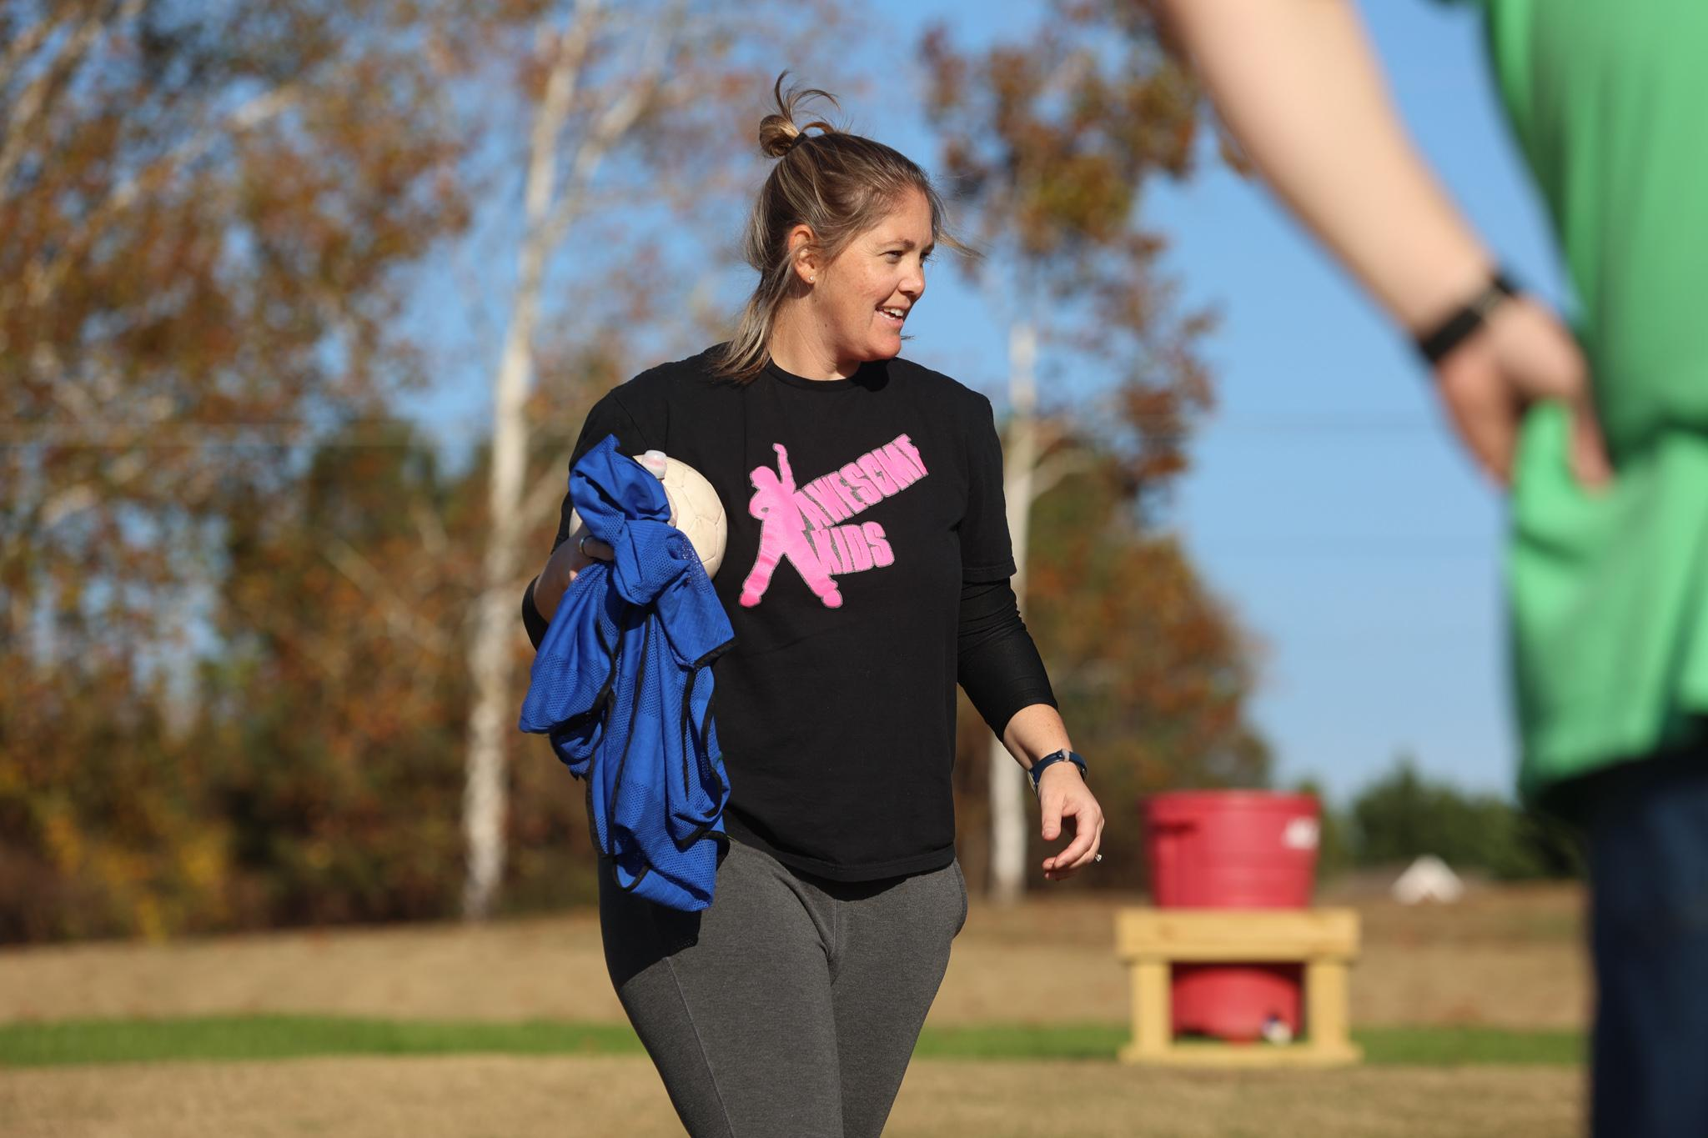
How Sam Snow’s backyard became her soccer future
The fields that are now Bluesprings Youth Soccer Association used to host a day camp for kids and adults with special needs — and the fields were Sam Snow’s backyard.
During the 1996 Atlanta Olympics, Snow and her family attended the women’s soccer games held in the University of Georgia’s football stadium. Her parents “caught the soccer fever” and turned their sheep fields into a soccer club. Their young daughter was one of the club’s first coaches. Starting at age 13, Snow headed out into the backyard to coach as a volunteer. During college, she’d come home to coach summer camps at the club.
Now, almost 30 years later, the club is home to over 1000 youth players, and Snow is the club’s executive director. But that’s not all Snow does. She’s also a coach educator, nonprofit director and former college head coach — all along the path back to the sheep fields near her childhood home.
“I always, always wanted to coach after I stopped playing,” Snow said. “I knew I wanted to stay in the game some way or another.”
Snow played collegiate soccer at Columbus State, but in her sophomore year, accumulation of concussions put her playing career on pause. Longtime Columbus State coach Jay Entlich brought Snow on as the team’s undergraduate assistant, and while she was doing “all the unglamrous stuff” like washing uniforms, she was also getting her first “amazing, amazing” experience coaching college soccer.
Snow transferred to UGA to finish her undergraduate degree, and while completing her last few semesters, she volunteered as a coach with Oxford College of Emory University, a junior college about an hour southwest of Athens. In her final semester, she got a call from the school’s athletic director, three weeks before preseason.
The head coaching role was suddenly vacant. Did Snow want it?
Surprised, Snow called Entlich, and he told her to call them back and say yes, of course. That chance to get head coaching experience was invaluable. Snow already had her A liscence, having spent every college summer taking coaching courses.
She took the gig and spent a decade as a head coach in the college game, later leading programs at Bluefield College and Georgia Southwestern. Snow was named to the National Soccer Coaches Association of America’s ‘30 Under 30’ program, recognizing the top thirty coaches in the country under thirty years of age.
As a part of that program, each honoree was paired with a mentor, and Snow’s mentor was Penn State women’s soccer head coach Erica Dambach. Dambach had led her program to an NCAA title and served as an assistant coach for the U.S. national team.
“She was a phenomenal mentor,” Snow said. “I just had my daughter, I was struggling through a hard college season, but she was awesome and supportive.”
Snow had the chance to spend a week shadowing the Penn State program and connected with Dambach throughout the season, getting advice over the phone.
When Snow’s daughter was diagnosed with autism in 2016, Snow again sought mentorship from Entlich, who reminded her that she could coach club soccer — and would be good at it, too. She interviewed at a few clubs, narrowed down her options, but at what Snow said was “the 11th hour,” her father called and offered her a position at Blue Springs, at home.
“Why didn’t you tell me sooner?” Snow asked. That option made most sense for their family at the time, and things “worked out the way they were supposed to,” she said.
Passing along her own coaching experiences, Snow teaches courses for U.S. Soccer and United Soccer Coaches. She previously served as the latter organization’s Women Advocacy Group chair. While Snow didn’t have many female educators leading her own coaching courses, she hopes to be that representation for other women pursuing higher licenses.
“It goes back to the age old, ‘If you can see her, you can be her,’” Snow said. “Also, it helps having somebody that you can talk to who has been through similar experiences. You don't want to work in a silo.”
Now, with Blue Springs — and its competitive side, UFA Loganville — Snow has found a passion for grassroots soccer and improving coaching communication and player retention at that level of competition. It opens up soccer to a whole community of players not seeking elite collegiate or pro opportunities, said Snow.
She is currently a trainer for U.S. Youth Soccer and U.S. Soccer Foundation program Soccer in Schools, which helps physical education teachers better coach soccer in P.E. courses. Snow also founded Awesome Kids, a nonprofit social and athletic opportunities for children with special needs, inspired by her own daughter’s autism diagnosis. One of the nonprofit’s programs, Awesome Soccer, is hosted at Bluesprings.
“I love how inclusive soccer is,” Snow said. “Anybody can play anywhere.”
It’s a matter of making playing, coaching and mentorship opportunities available for all, and for Snow, it started in a sheep field.

